**MAGIC BOOK 2**

UNIT 1- LESSON 1

  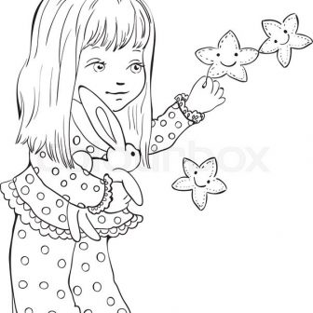

happy=_________ strong=__________ little=___________

girl=___________

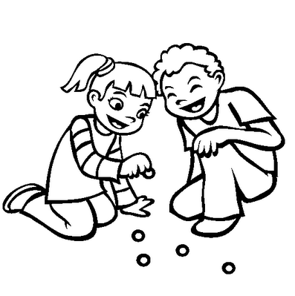 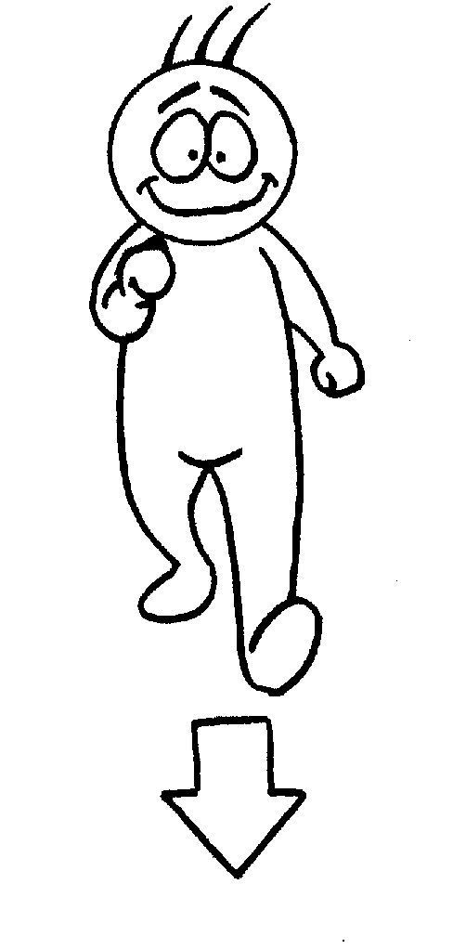 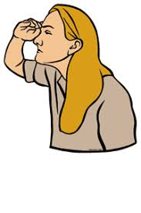

play=___________ come=________ look for=_________

Come on!=______

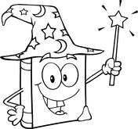  

magic=_________

book=-________ things=_____________ all day long=______

Who?=____________

Who’s this?=______________

UNIT 1 – LESSON 2

 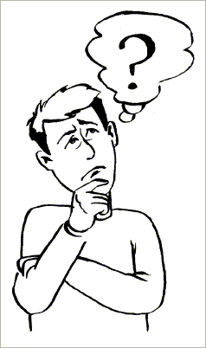 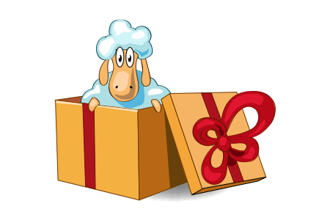 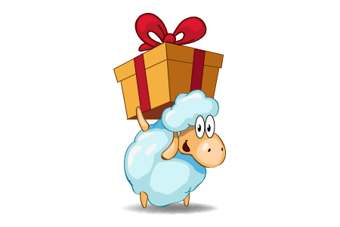

Where?=________ What?=________ in=________ under=_______

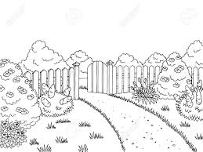 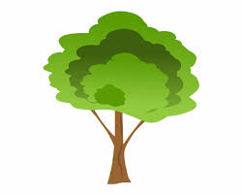 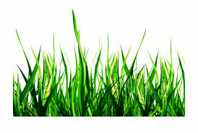 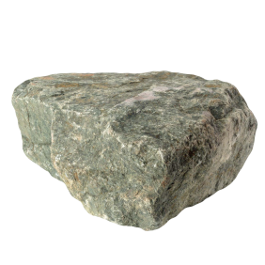

garden=________ tree=_______ grass=________ stone=____

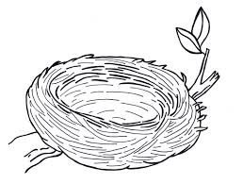 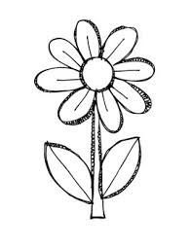 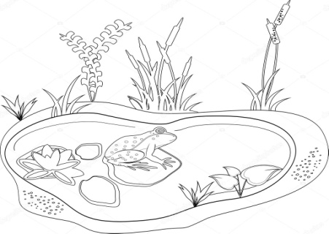

nest=_________ flower=________ pond=__________

 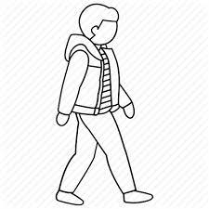 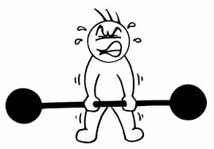

look=__________ walk=_________ try=_______

Let’s try it!=___________

 

I’m so excited=____________ Great!=______________

* In here=_________ of course=___________ Me too!=__________

UNIT 1 – LESSON 3

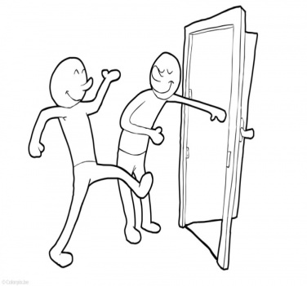 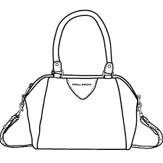 

open the door=___________ bag=___________ box=_______

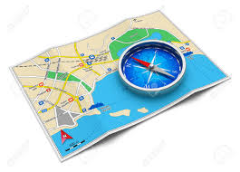  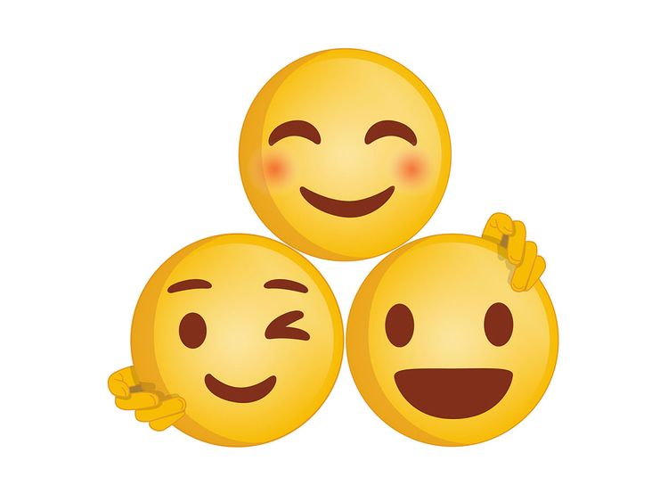

map=_________ pirate=__________ together=_________

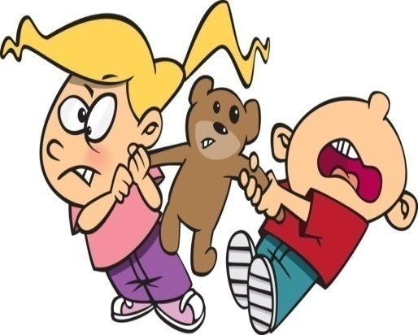 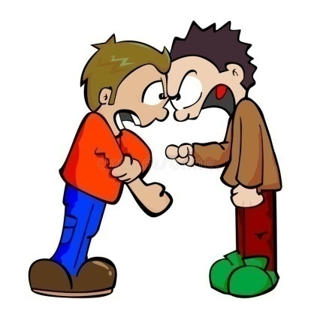

It’s mine!=___________ Friends don’t fight!=______________

Can you….? =______________

Yes, I can! =___________ No, I cant’!=_____________

UNIT 2- LESSON 1 (The magic map)

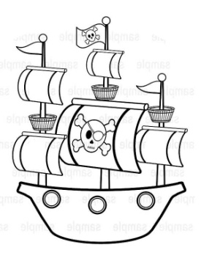 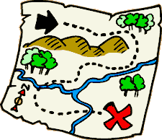 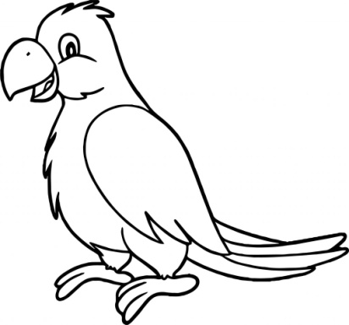 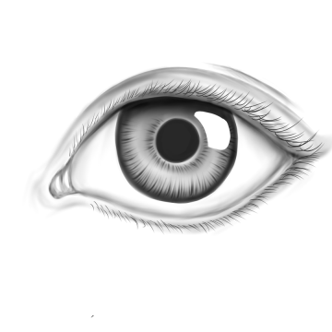

(pirate) ship= treasure hunt= parrot=_________ eye=______

__________ ____________

 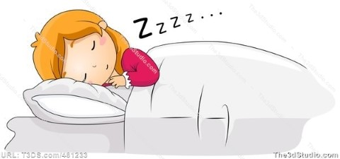 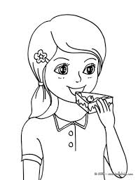 

read=________ sleep=__________ eat=_________ tooth=______

 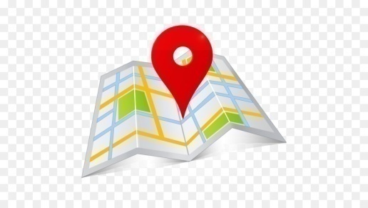 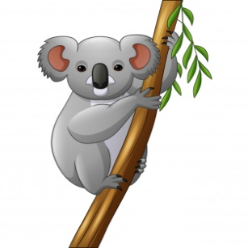

message=_________ find=___________ koala=_______

* Can you help me?=________________
* Of course!=___________
* I want to…… =___________
* Where can you find……?=_____________

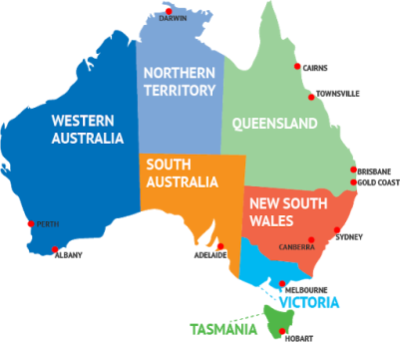 Australia=________

UNIT 2- LESSON 2 (On the big island)

 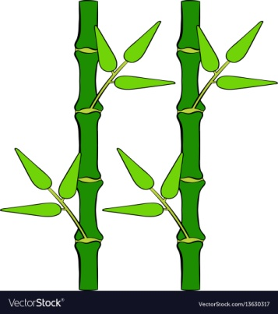

welcome=_______ bamboo=_______ leaf=______

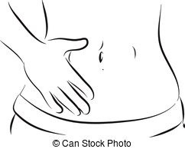 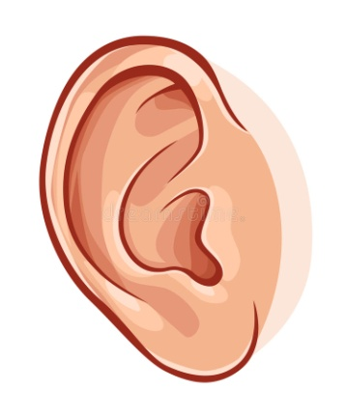 

tummy=­­­­­­­­___________ ear=_________ mouth=_________

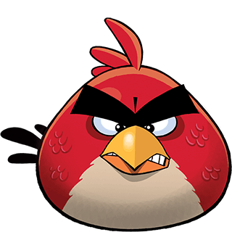 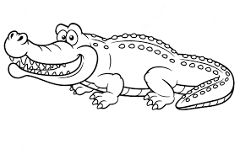 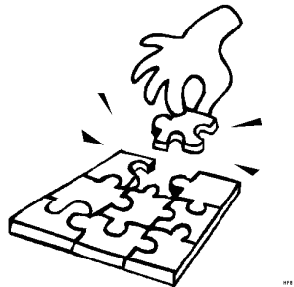

angry=___________ crocodile=_________ puzzle=___________

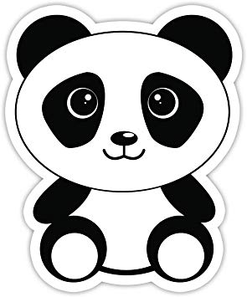  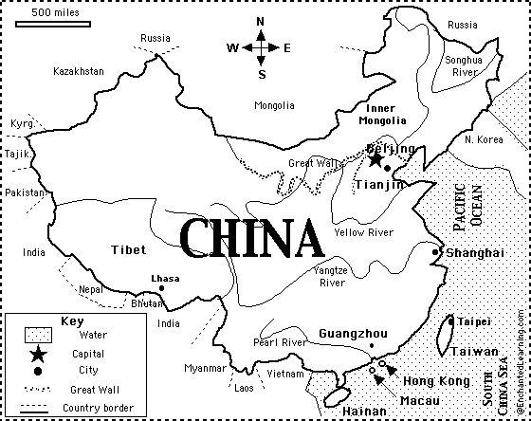

panda=______ Don’t be afraid! =__________ China=_________

afraid=_____________

UNIT 2- LESSON 3 (The dragon’s house)

 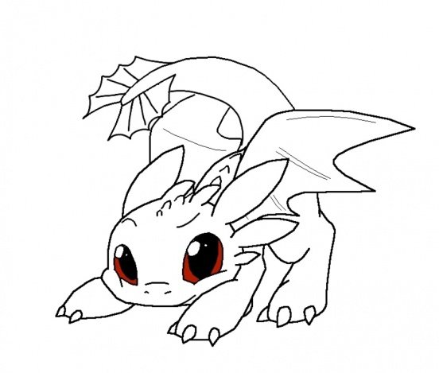 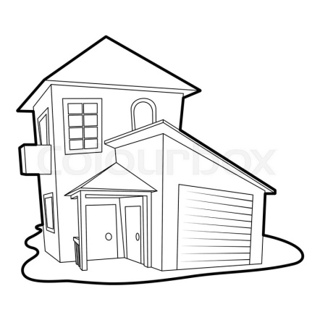

follow=_________ dragon=_________ house=________

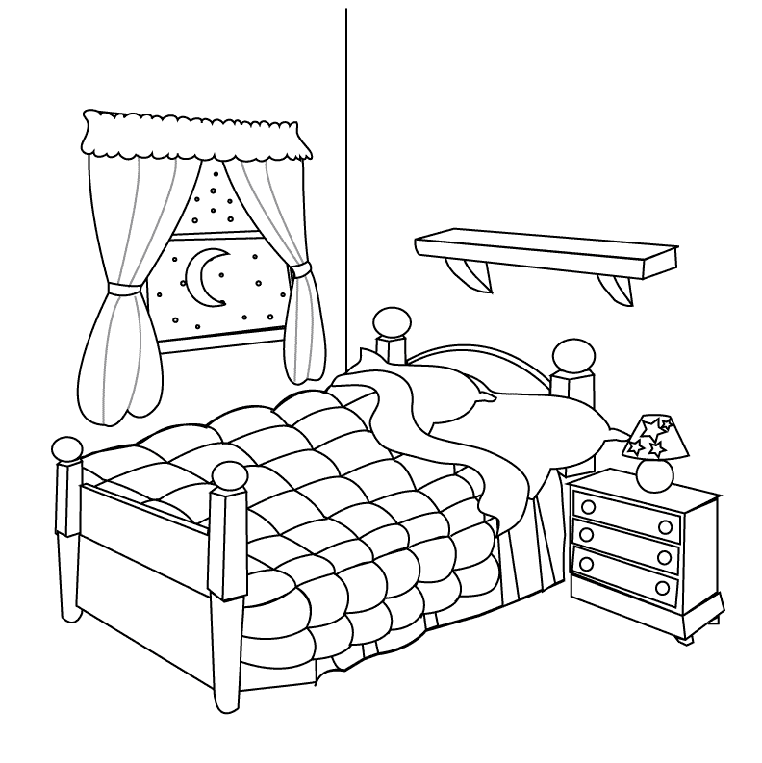 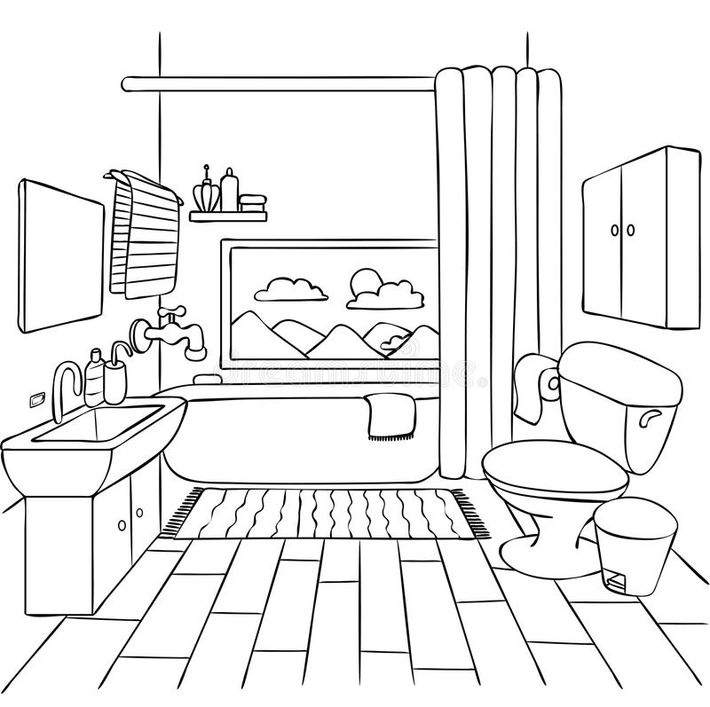

bedroom=__________ bathroom=____________

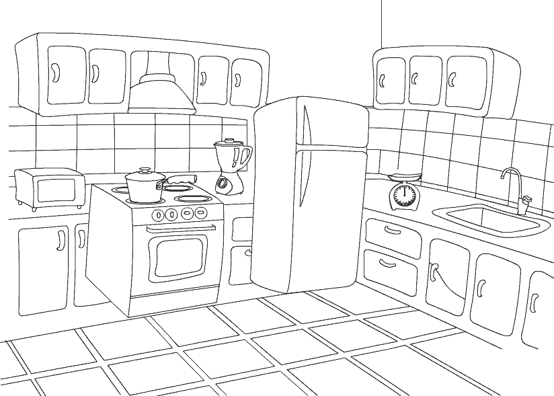 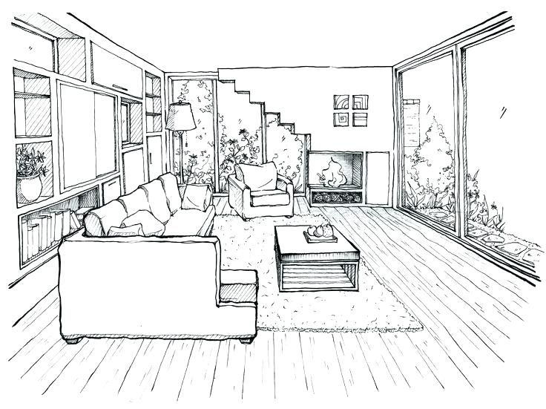

kitchen=____________ living room=____________

* Nice to meet you!=_____________

UNIT 3- LESSON 1 (IT’S SUMMER)

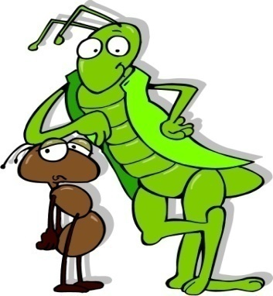

cricket=__________

ant=____________

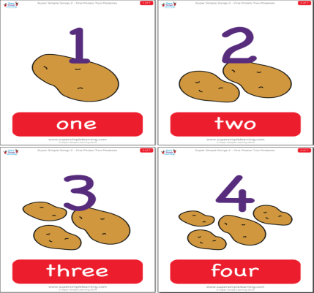  

potato= ___________

potato**es**= _________

It’s (so) hot=

____________ work=_________

 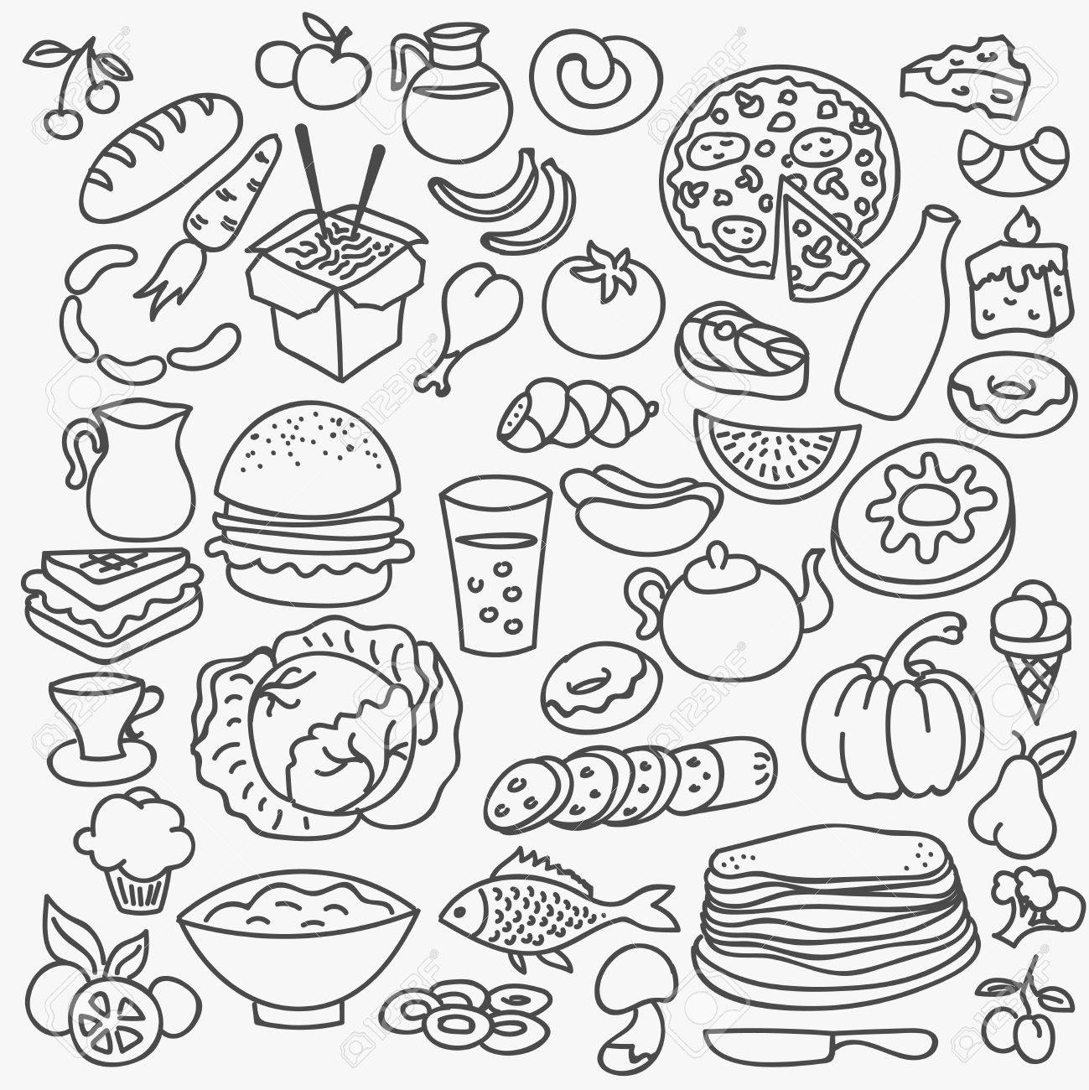 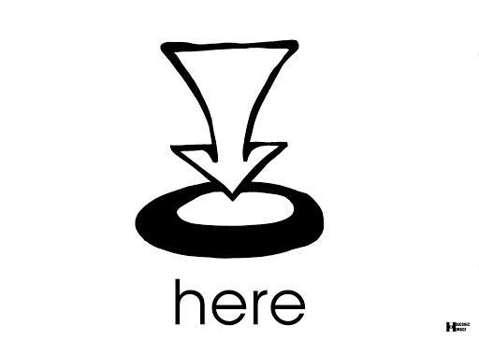 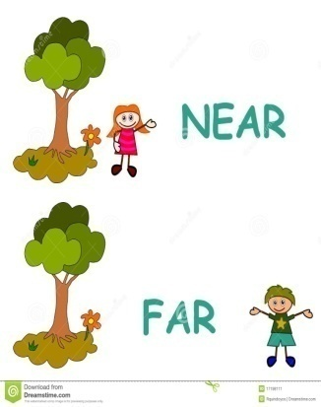

save=_________ food=__________ here=________ near=_______

I’m saving food=__________________

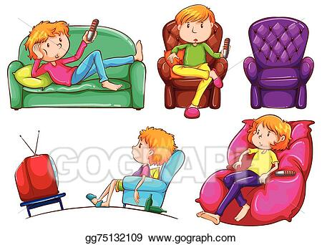

* Why?=____________
* only=________
* today=__________
* another day=____________

Don’t be lazy=_________

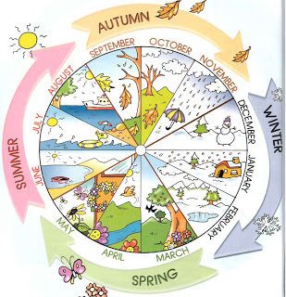

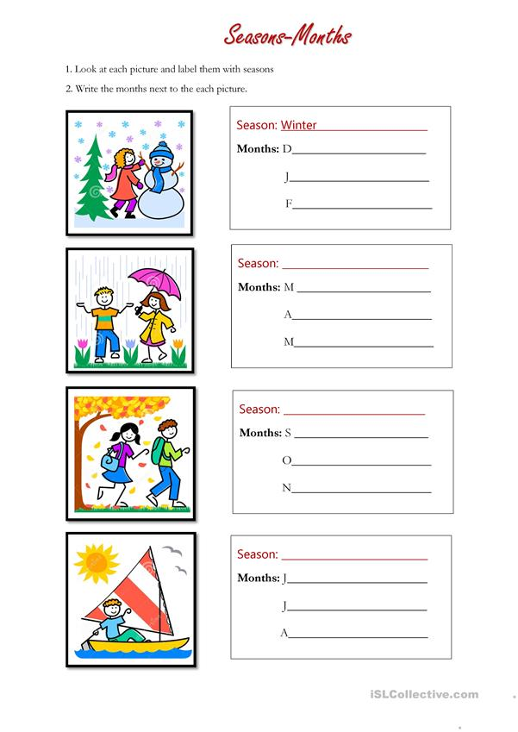

UNIT 3 – LESSON 2 (AUTUMN’S HERE)

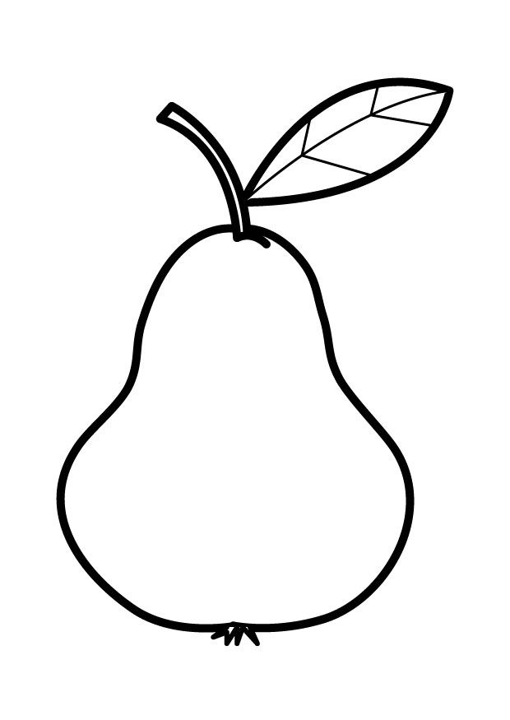 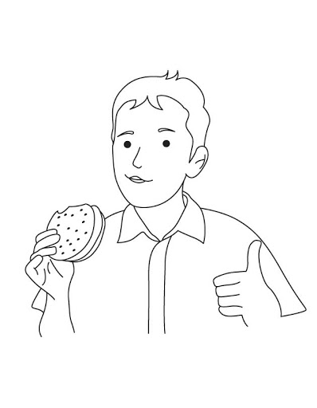 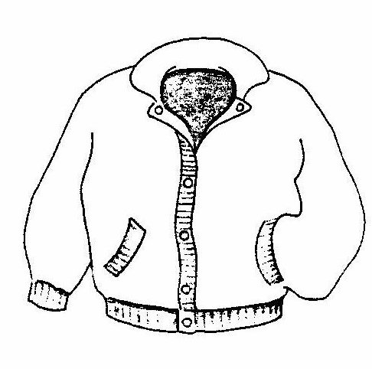

pear=___________ yummy=___________ jacket=__________

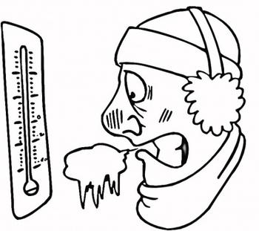

* It’s cold=______________
* I’m cold=______________

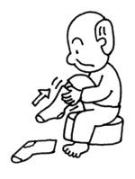 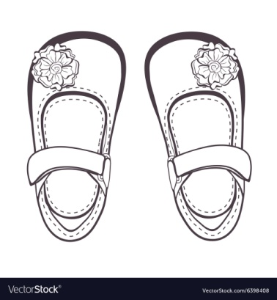 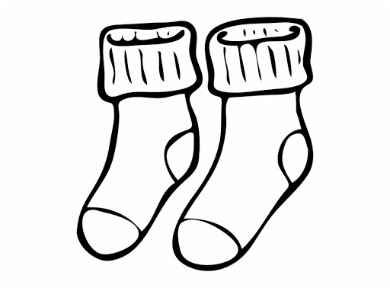

put on=___________ shoes=___________ socks=___________

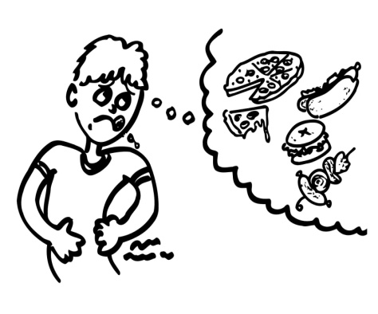 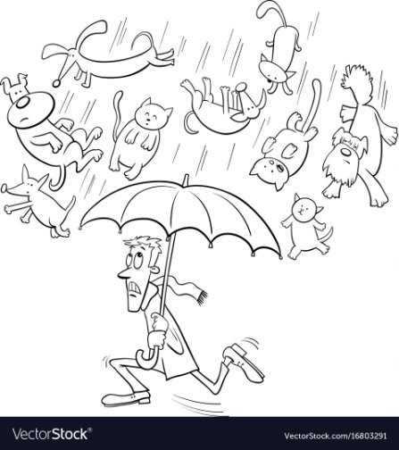

I must…=Εγώ πρέπει να…

(He must wash his hands)

hungry=_______________ It’s raining=__________

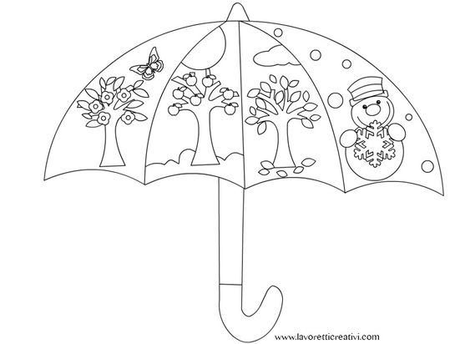

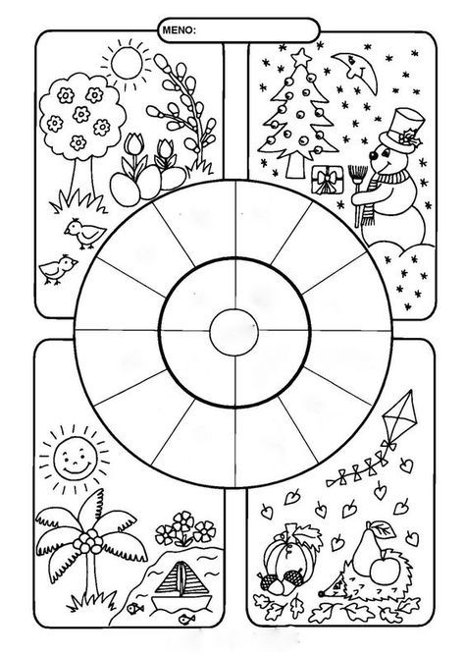

UNIT 3 – LESSON 3 (IT’S WINTER!)

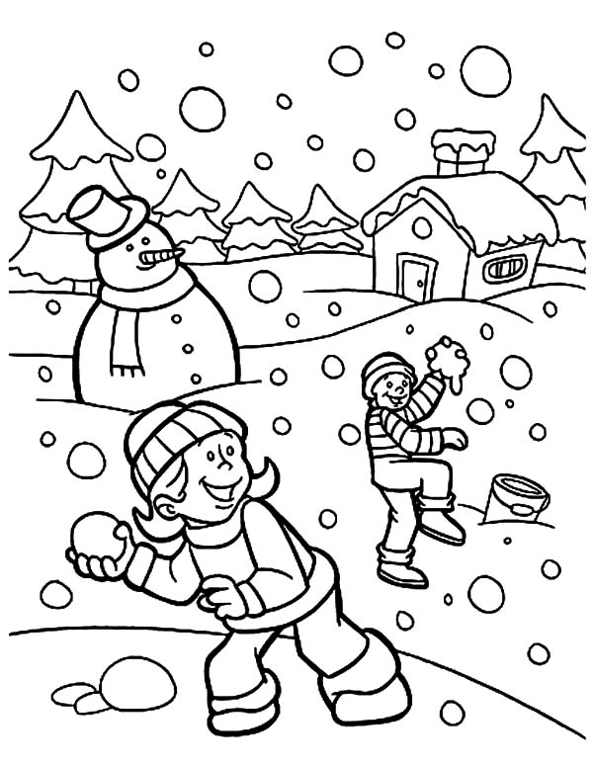 

sun=_______

sky=_______

It’s snowing=___________

 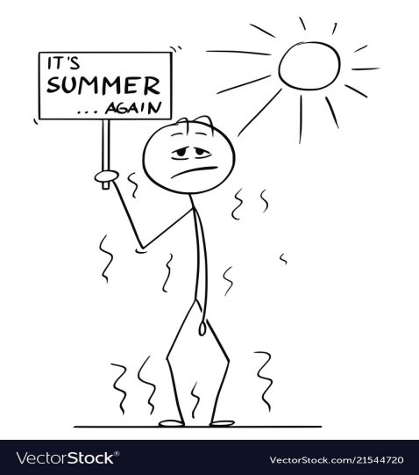 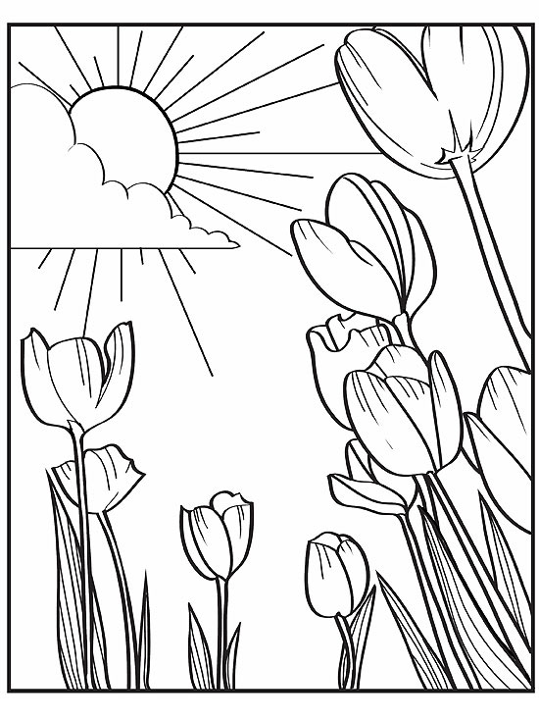

It’s cold=_________ It’s hot=__________ It’s warm=____________

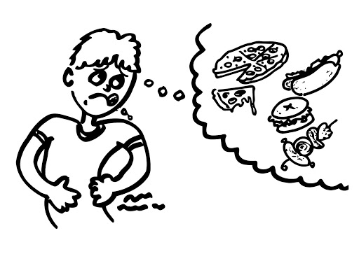 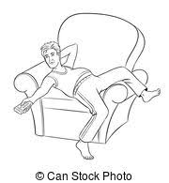 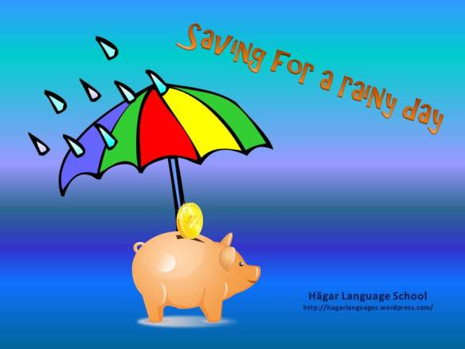

hungry=___________ lazy=_________ save for a rainy day=_____

I’m hungry=__________ ____________________

UNIT 4 – LESSON 1 (THE WEASEL AND THE MOLE-IN THE CELLAR)

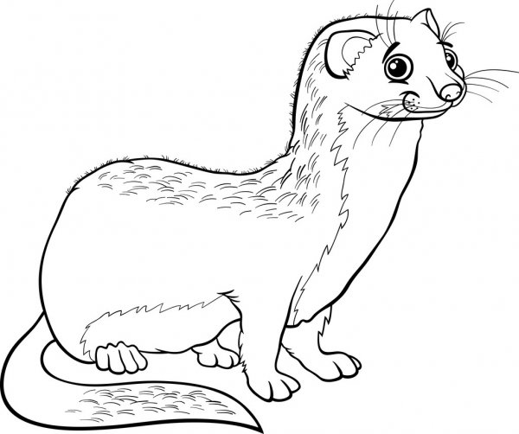 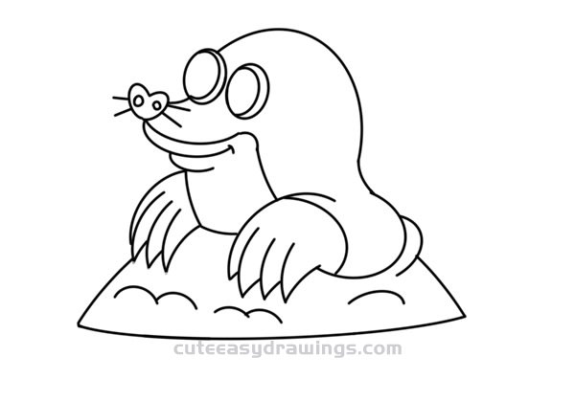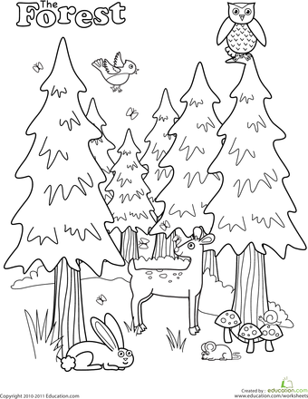

weasel=__________ mole=____________ forest=_____________

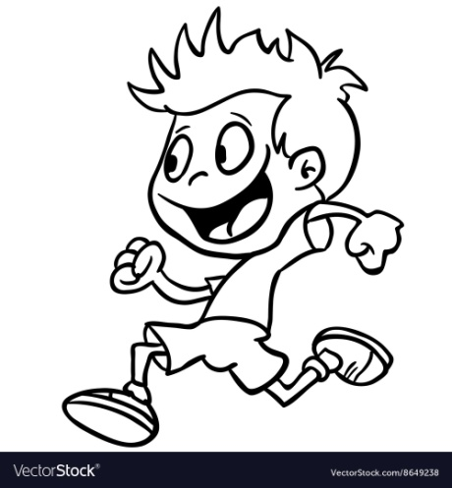 run=________ 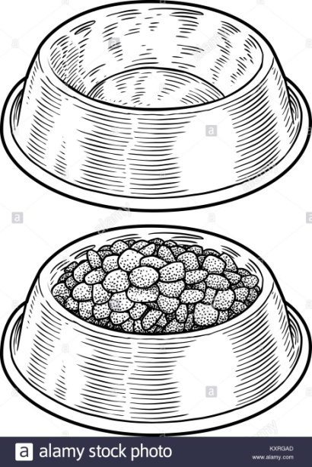

empty=

________

full=

_________

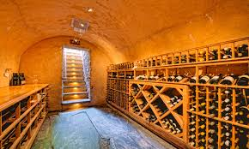  

cellar=__________ wall=_________ hole=____________

small=____________ 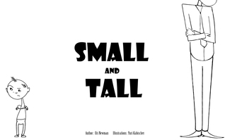 tall=_________

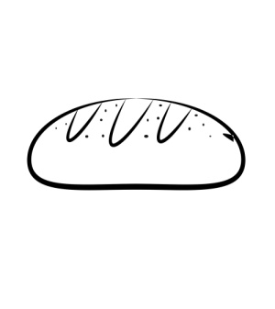 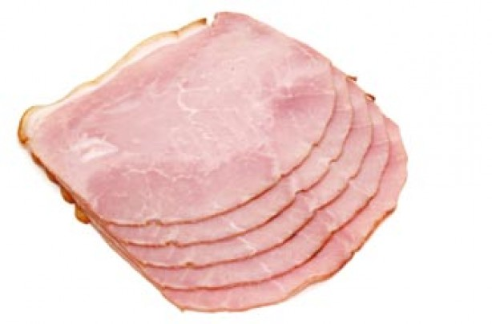 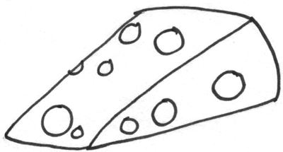 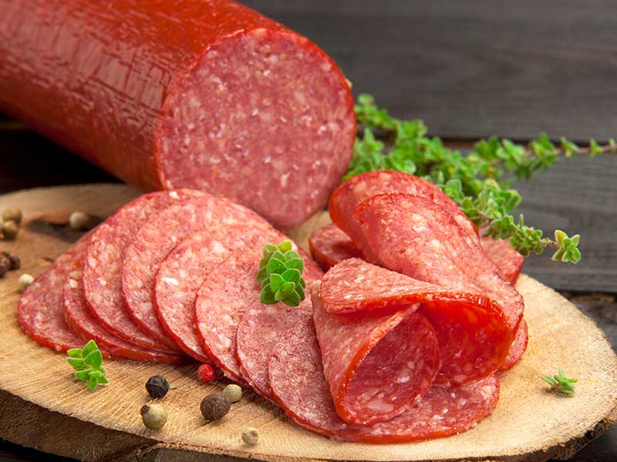

bread=_______ ham=_______ cheese=________ salami=_________

There’s … =_________

Join me! =___________

Have some =_________

Time for lunch=_______

* What? = ________

What are you eating? =____________

* Why? =________

Why is he running? =_____________

**PRESENT CONTINUOUS**

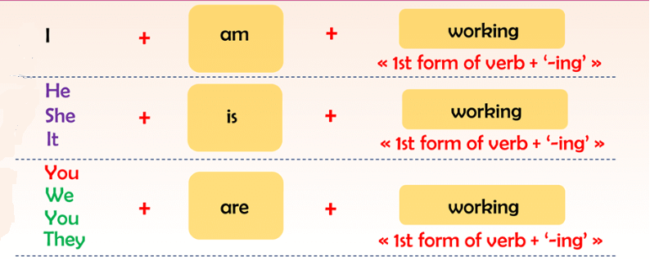

* για κάτι που κάνω ΤΩΡΑ!

UNIT 4 – LESSON 2 (TIME FOR LUNCH)

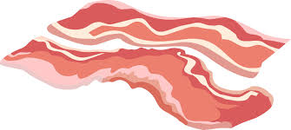  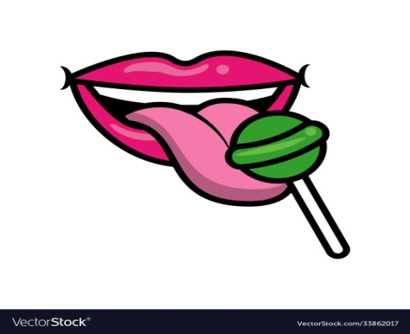

bacon=________ lips=_______ lick = ___________

lollipop=___________

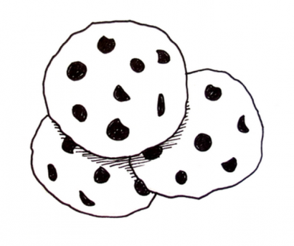 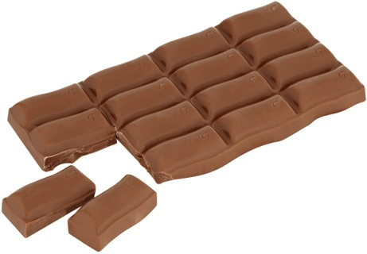 

cookies=________ chocolate=_________ munch/crunch=_________

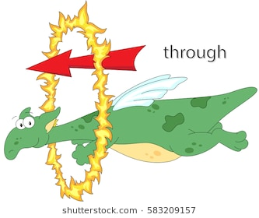 

through=_________ big=_______

fat=_______

UNIT 4 – LESSON 3 (THE RIGHT KIND OF FOOD)

 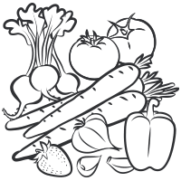 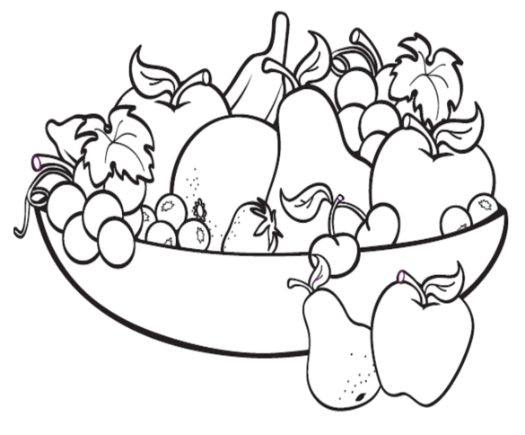

Don’t pout=__________ vegetables=__________ fruit=_________

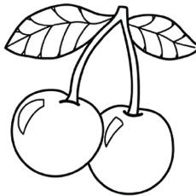 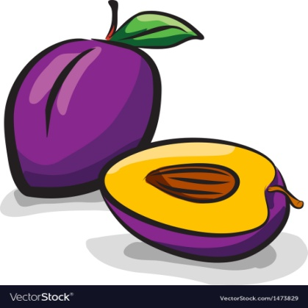 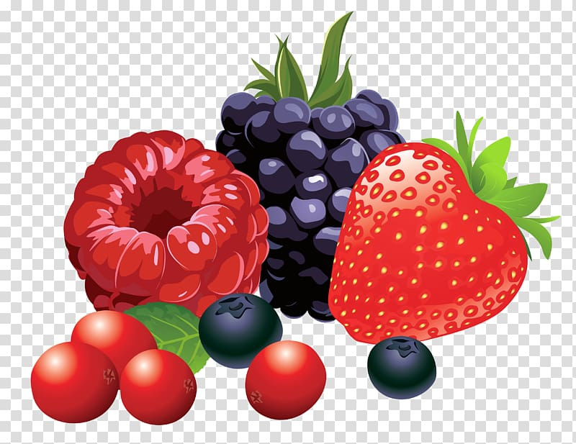

cherry=________ plum=__________ berries=___________

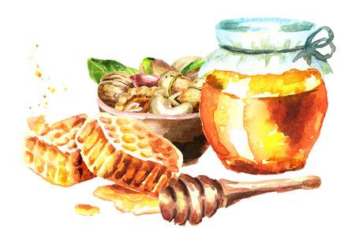 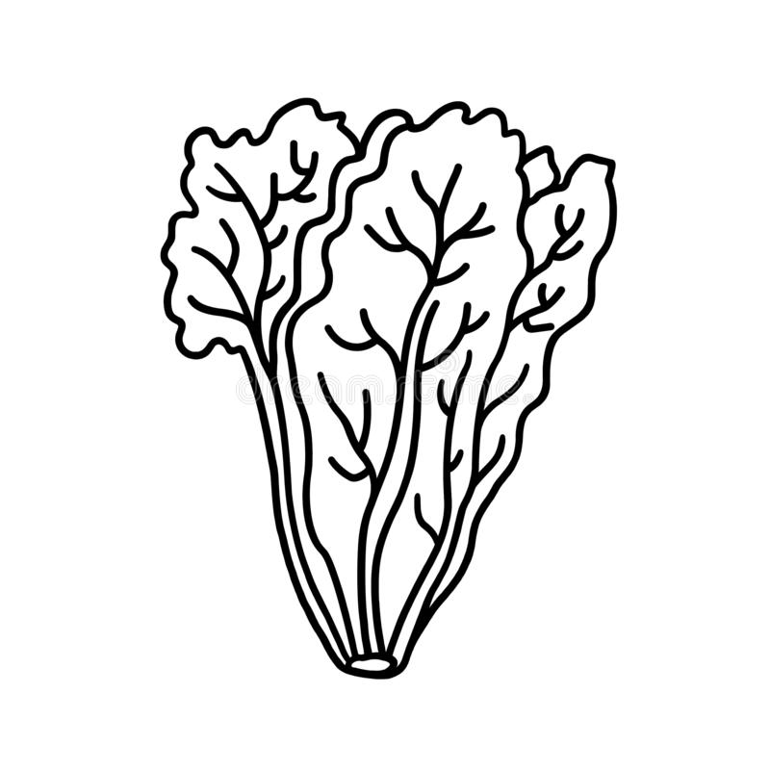 

honey=_________ lettuce=__________ thin=________

nuts=___________

* RIGHT! = Σωστά!- Σωστός
* Υοu are right! = Έχεις δίκιο!
* right kind of food= το σωστό είδος φαγητού
* Ι’m out of here!= Φεύγω!
* Thanks a million! = Χίλια ευχαριστώ

(million= εκατομμύριο)

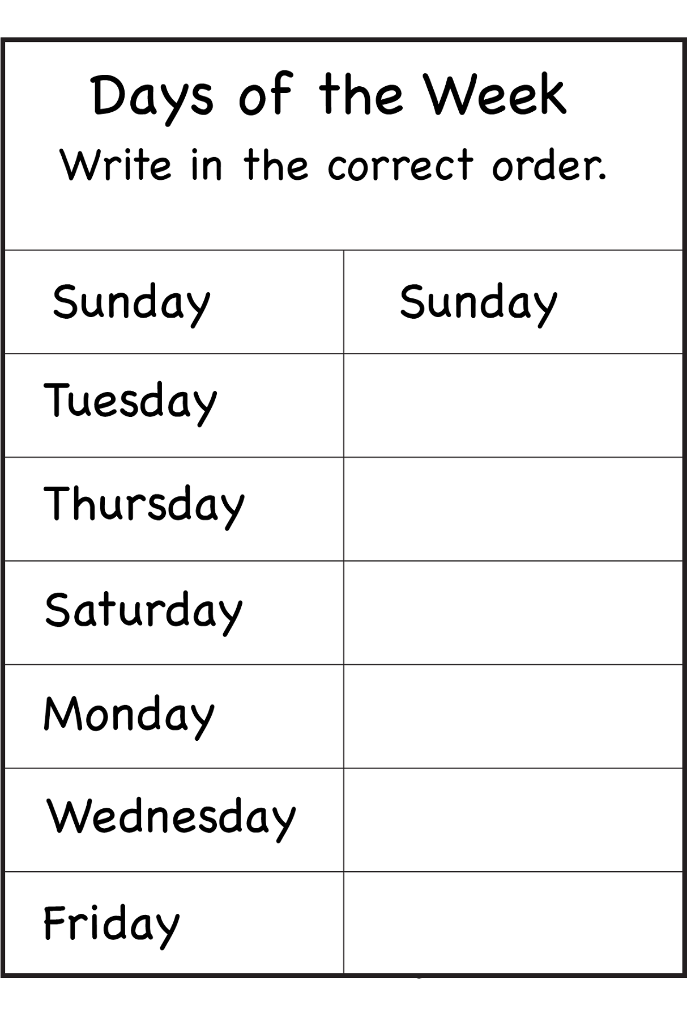

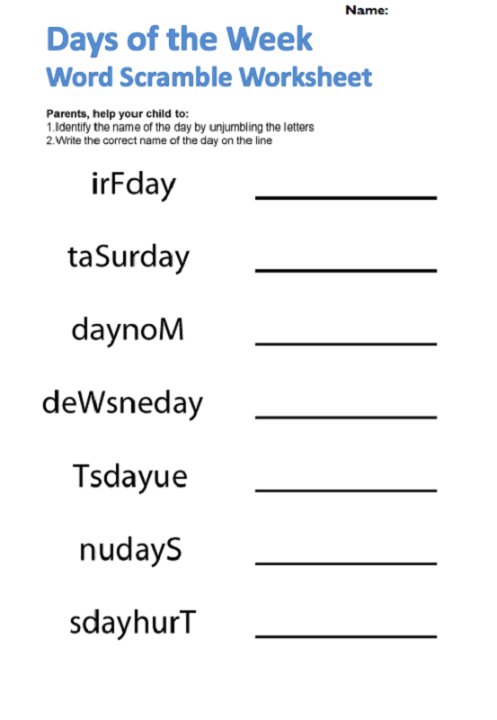

UNIT 5 – LESSON 1 (THE ANIMAL SCHOOL)

 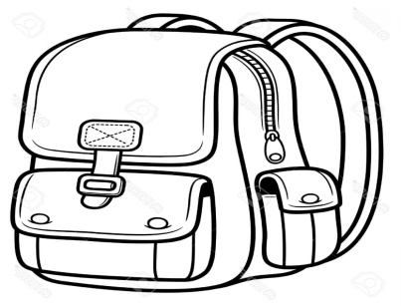 

rubber = ________

pencil = ________

school =_________ schoolbag = _________

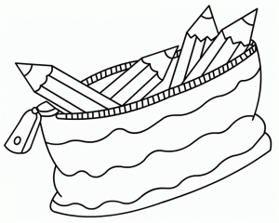 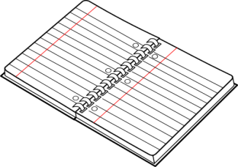 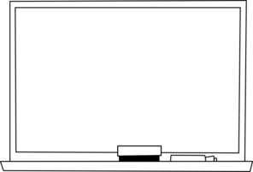 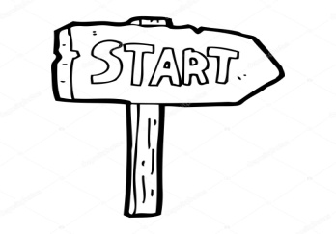

pencil case =______ notebook = _______ board =_________ start=______

 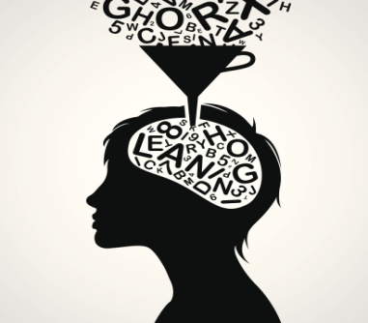 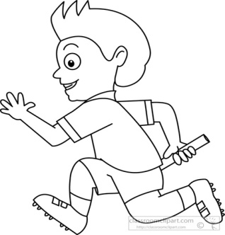 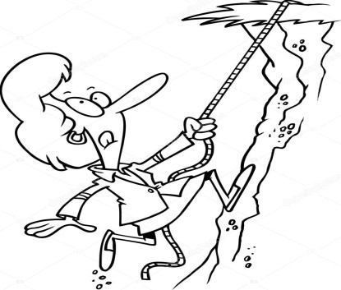

I’m so excited= learn= _________ running (run)= climbing (climb)=

___________ _____________ ____________

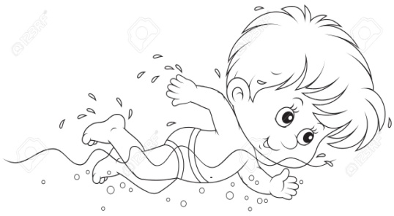 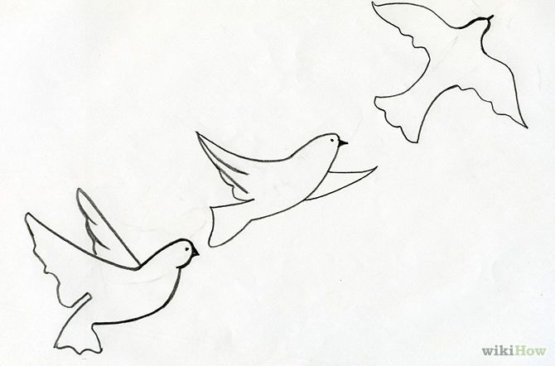 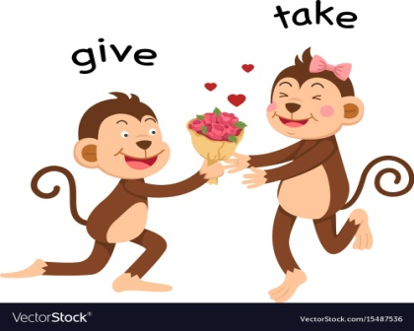

swimming (swim)=________ flying (fly)=__________ take=_______

* We want to…= Εμείς θέλουμε να…
* School is fun!= Το σχολείο είναι διασκεδαστικό!
* We don’t need…= Εμείς δε χρειαζόμαστε…
* Where?= Πού;

UNIT 5 – LESSON 2 (LESSONS AT THE ANIMAL SCHOOL)

 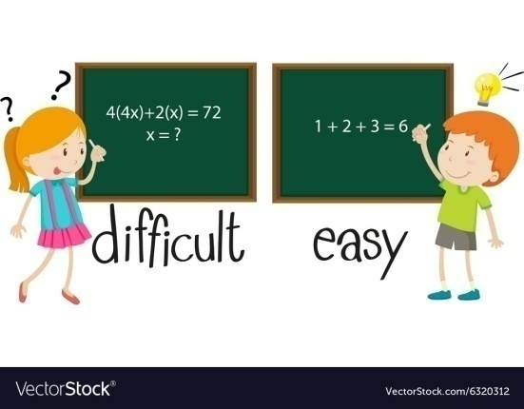

easy=

_______

hard=

_______

I love…=____________

 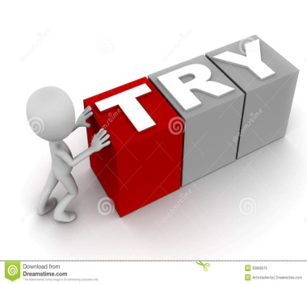 

Ι don’t like=________ try=___________ Don’t be angry!=_________

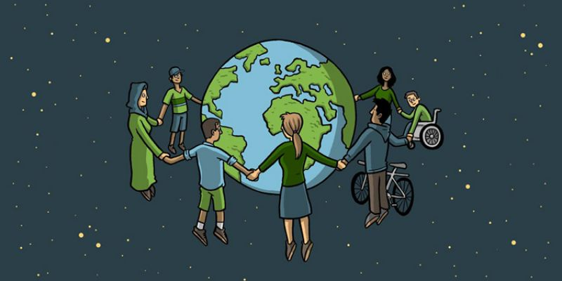 together=_________

* Let me try = Άσε με να δοκιμάσω/προσπαθήσω
* Let’s try =Aς δοκιμάσουμε/προσπαθήσουμε
* Time for… = Ώρα για…
* It’s……… o’clock = Είναι ………… ακριβώς
* It’s half past ………= Είναι ……… και μισή
* CAN = ΜΠΟΡΩ 🡺 I can fly/I can’t fly/ Can I fly?
* MUST= ΠΡΕΠΕΙ🡺 I must try/I mustn’t try/ Must I try?

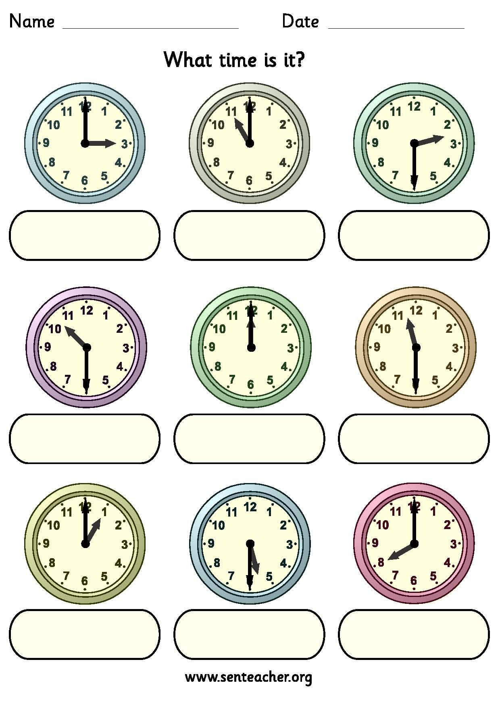

UNIT 5 – LESSON 3 (A BRIGHT WORLD)

  

It’s cool=______ different=________ unique=____________

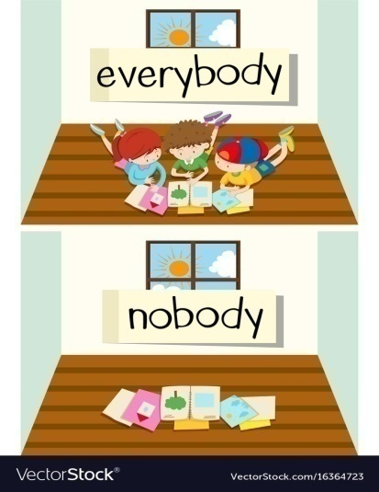 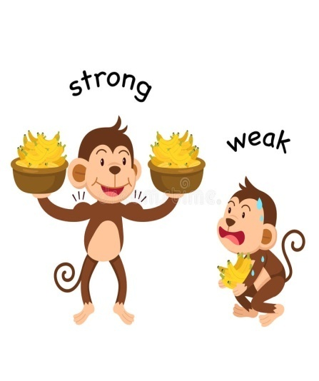

weak=________

nobody=________

everybody=_______

boring=________respect=­­­­­­______

* What a pity! What a shame!= Τι κρίμα!
* Respect my rights= Σεβάσου τα δικαιώματά μου (right=δικαίωμα)
* Everybody can do something= όλοι μπορούν να κάνουν κάτι

Together we can do everything= μαζί μπορούμε να κάνουμε τα πάντα

UNIT 6 – LESSON 1 (NOTHING LOOKS RIGHT)

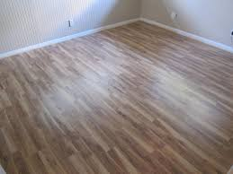

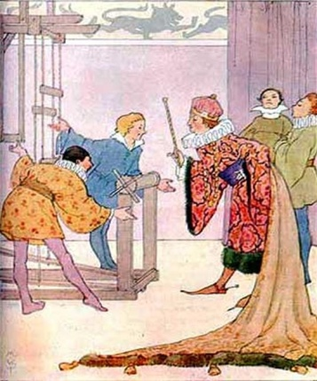 

floor=_______ emperor=_________ change=____________

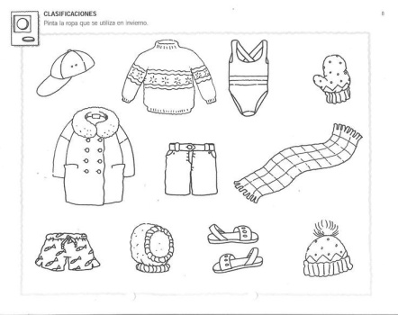 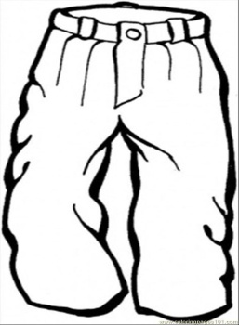 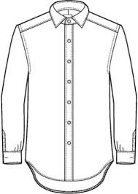 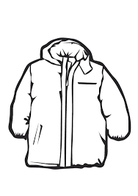

clothes=__________ trousers=______ shirt=______ jacket=_______

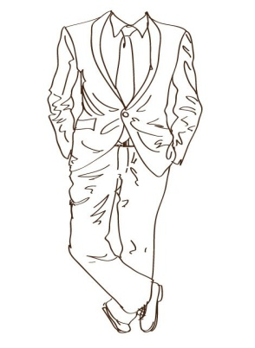 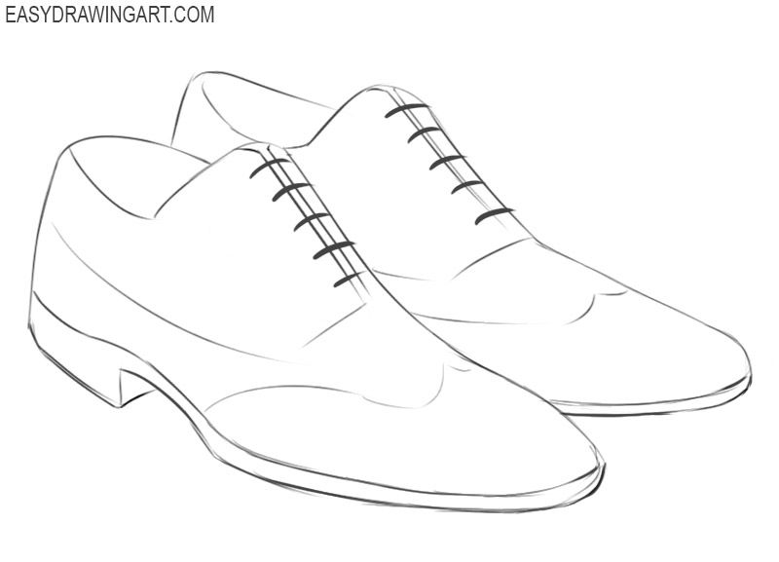

suit=________ shoes=_________

UNIT 8 – LESSON 1 (THE PALACE OF MINOS)

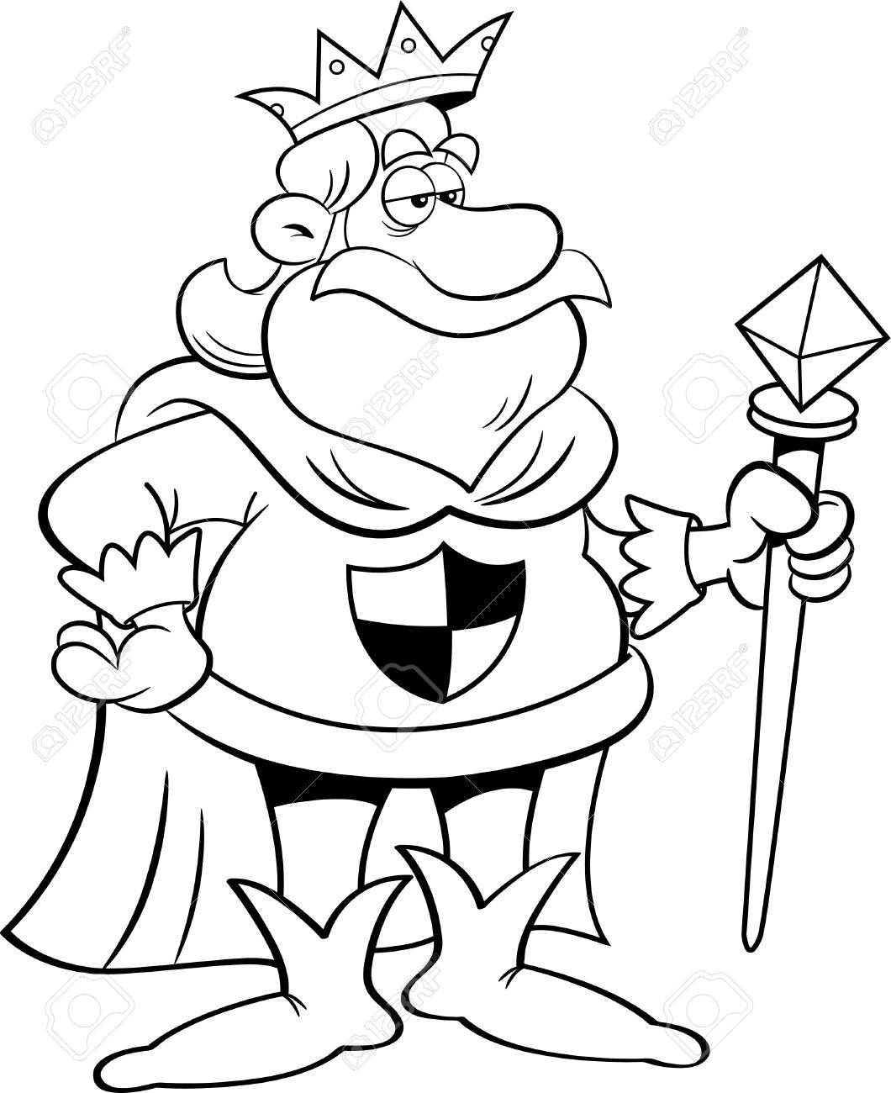 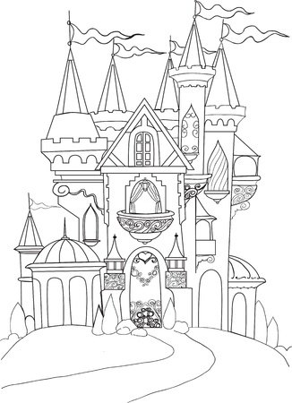 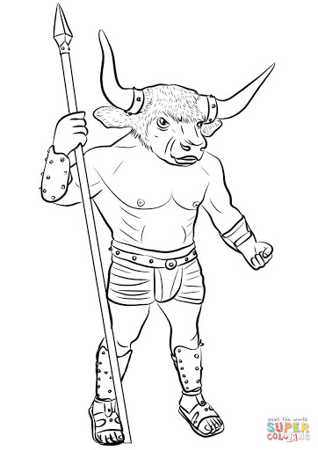

king=________ palace=________ Minotaur=_________

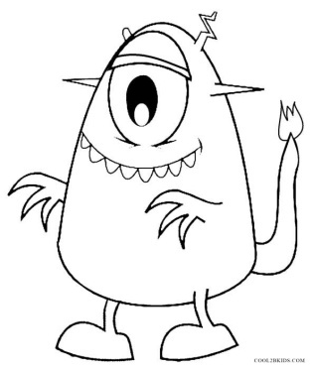 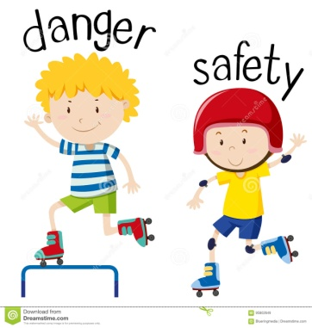 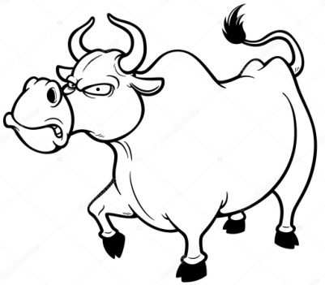

monster=__________ dangerous=___________ bull=_________

safe=____________

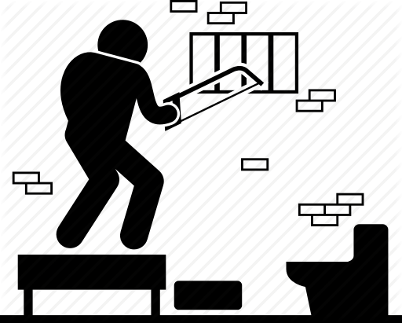 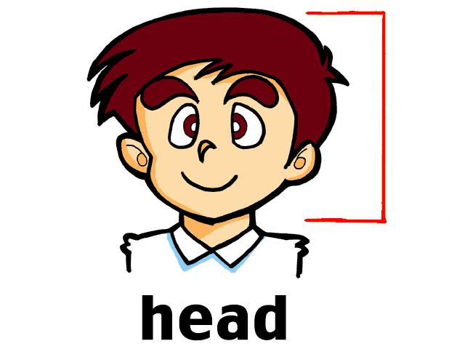 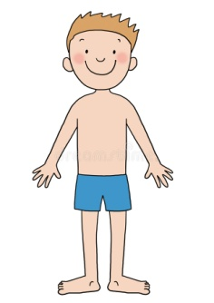

escape=__________ head=_________ body=_________

prison=__________

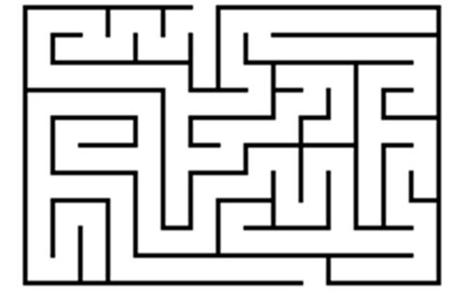 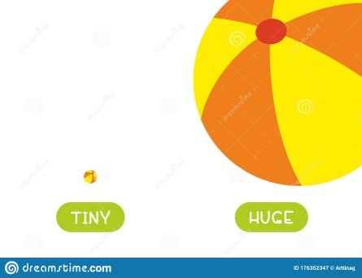 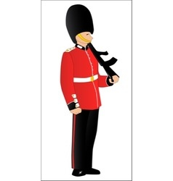

maze=__________ huge=__________ guard=_________

* Thank you=___________
* You’re welcome=__________
* no one=nobody=_______
* (he) can do no harm= δεν μπορεί να βλάψει
* Ι can’t let you leave!= Δεν μπορώ να σας αφήσω να φύγετε!

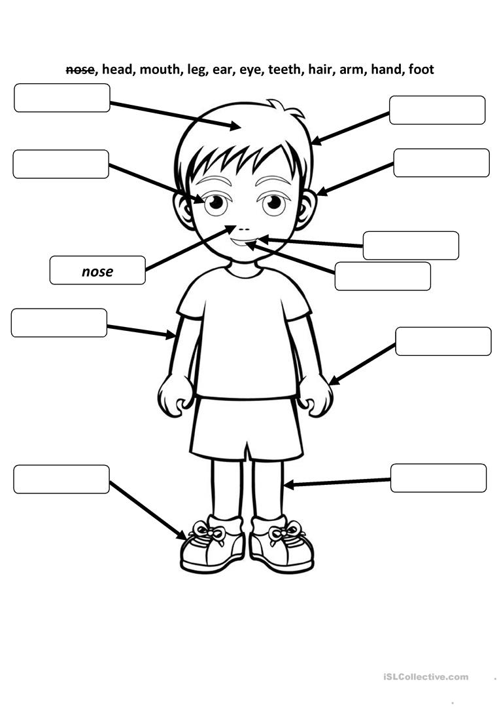

UNIT 8 – LESSON 2 (IN PRISON)

 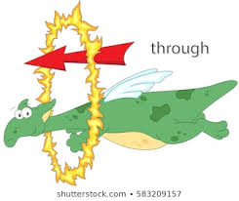 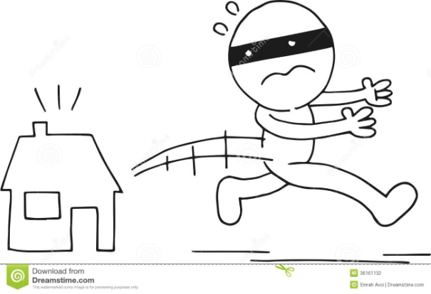

greedy=_________ through=_________ get away (from)=__________

wing=_______

feather=________

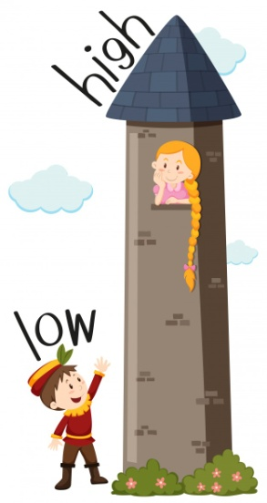 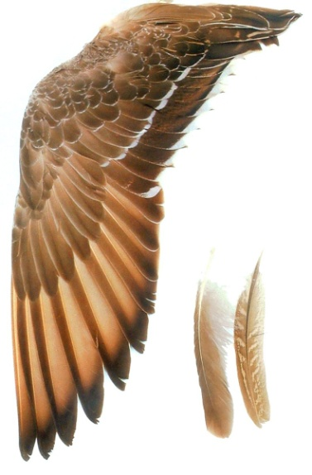

high=_______

low=________

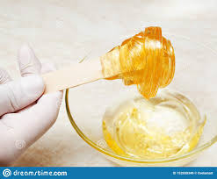

stick=_________ wax=____________ rest=____________

* have to=must= _________
* We have to find a way to escape=_________ να βρούμε έναν τρόπο να __________
* What about…? = Τι λες για…;
* brilliant idea= εξαιρετική/φανταστική/απίθανη ιδέα
* We only need…= Χρειαζόμαστε μόνο…

UNIT 8 – LESSON 3 (ICARUS IN THE SEA)

  

remember=_________ melt=_________ tiny=_________

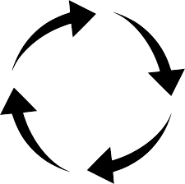 

round and round=________ up and down=________ fall down=_______

* Stay close to me= Μείνε κοντά μου
* …and one more thing= …και κάτι ακόμα
* You are getting close to the sun= Πλησιάζεις τον ήλιο