Name:
Answer these questions. Vocabulary

- I’m on holidays and every night l late.
- ship
- fly
- caves
- brush my teeth
- together
- island
- go to bed
- often
- ship
- cake war
- Most birds can but penguins can’t.
- My dentist says l must two times a day.
- Evoia is the second largest in Greece.
- How do you eat ice-cream in winter?
- My brother and l often play board games
- When we travel to Crete, we usually go by
- In south Evoia you can see the famous Dragon
- I have never played but l would like to as l love cakes and l think it would be funny.
- My brother and l would really love to the cave but our parents won’t let us.

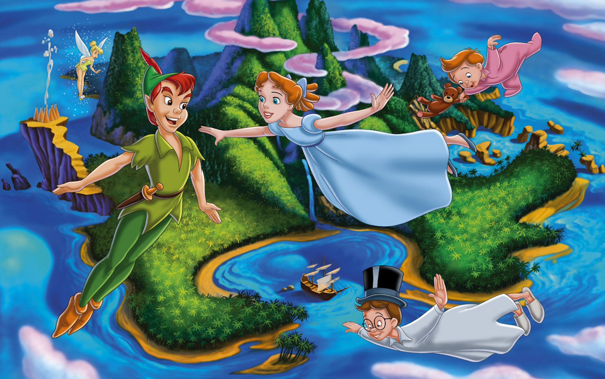
Answer these questions: Text
- Who has the dream?
- Where is she in this dream?
- Who is she with in this dream?
- Does she have good habits in this dream?
- Does she go to school?
- Does she eat unhealthy food?
- What’s her favourite game?

