HALLOWEEN
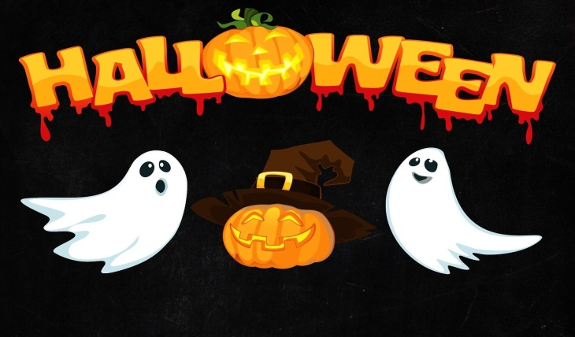

TREASURE / SCAVENGER
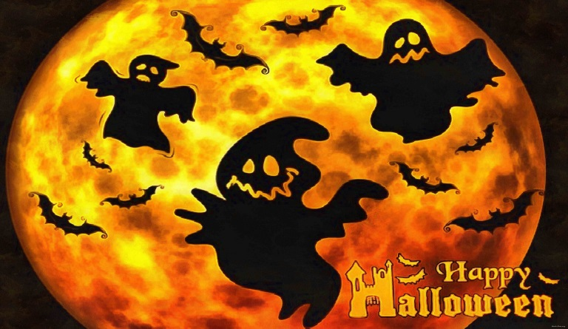

HUNT
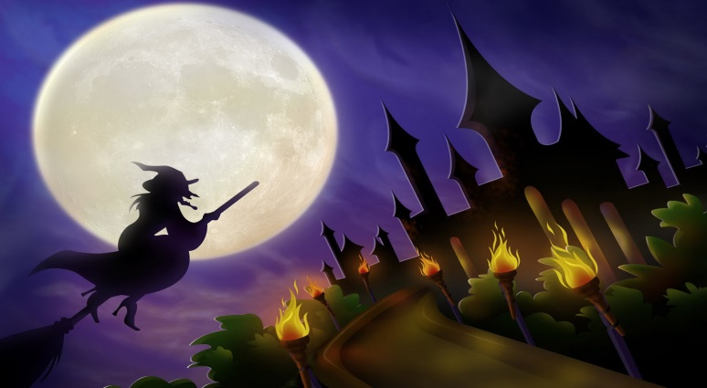
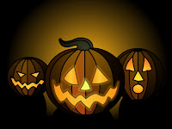 10

I have keys but no locks.
I have a space but no room.
You can enter, but can't go outside.
I have your next clue.

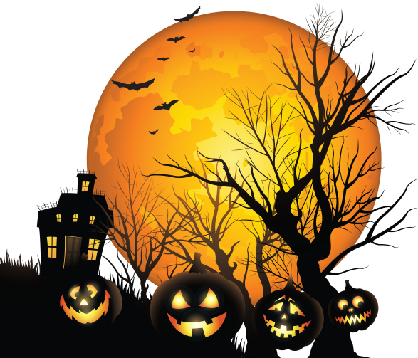 9

There are a lot of me on schools
On a car and your home too
Made of glass and can be opened
In order to let air through.

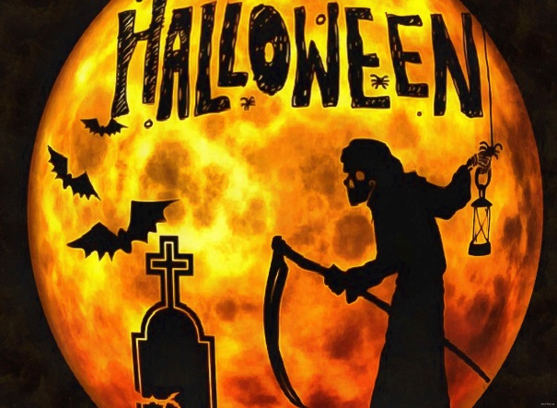 8

Your next clue can be found, in something orange and round.

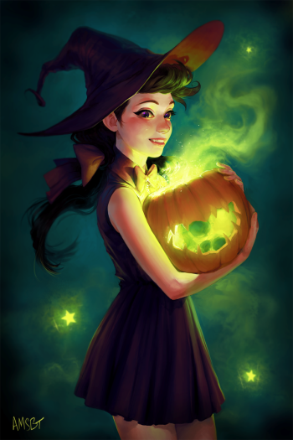 7

Where teachers rest? Find this clue and do your best.

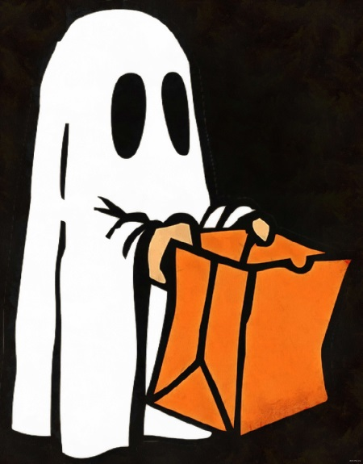 11

I’m green, brown, and tall.
I change colors during the fall.
I’m not a dog but I have a bark,
When it’s winter, I look bare and stark. There is your clue but watch out for the Halloween ghost…….

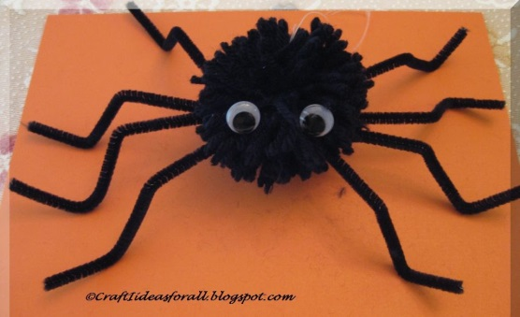 12

Spiders have eight legs.
I have four legs but I’m not a dog
I have a back but I’m not a camel
I sometimes have arms but I don’t have any hands
I can be sat on but I’m not a horse
I’m a piece of furniture but I’m not a bookcase.
What Am I?
Underneath it does your next clue hide.

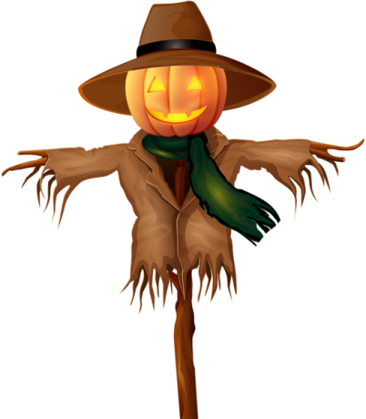 13

Scarecrows don’t scare me and neither do teachers. Your next clue is hiding in the teacher’s office who is in charge of this school.

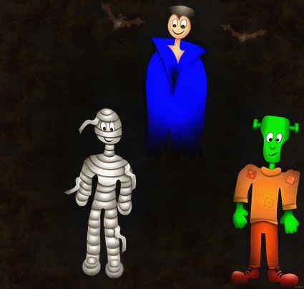 16

‘Trick or treat’ said the vampire to the mummy. But the monster had the clue…..
Take note of all I say
Observed only by day
Looked at by all bar teach
With pen to me you reach

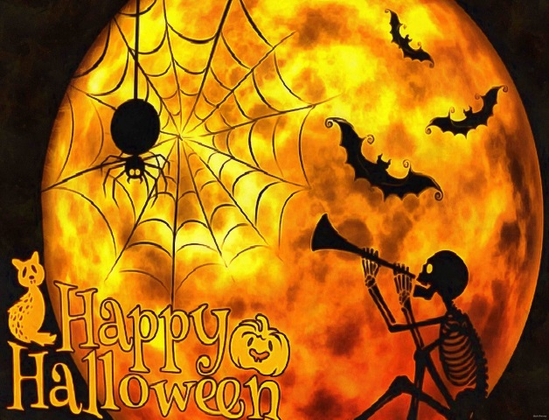 17

Happy Halloween! Congratulations!!!!
Say the Magic Words and get your reward…

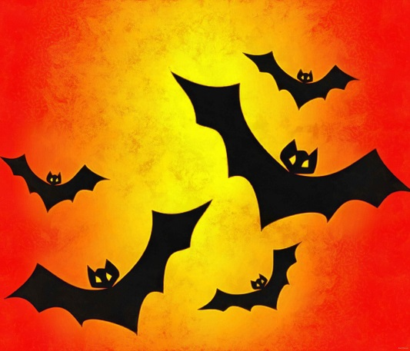 6

Your teacher is in class. Have you got English? May be a test. Look for it. Where is it? Maybe in the ……

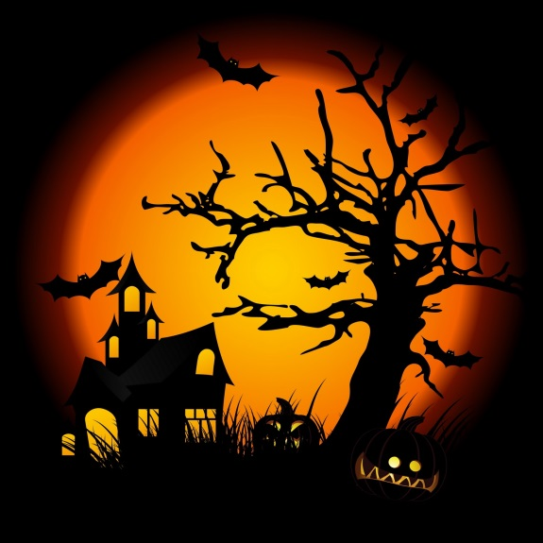 1

This year in order to get your Halloween treat you’ll have to follow the clues and have fun. A spooky Halloween has begun! You’ll find the first clue if you answer - What word has 26 letters but only three syllables?-Where am I?

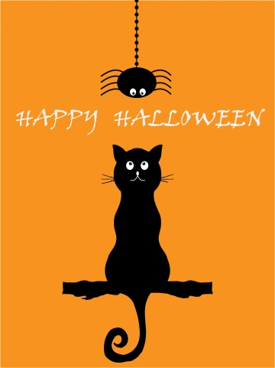 5

Black cat, black cat, what do you see?
I see a brown spider looking at me. But Where are you?
I am in a class full of children around five- six years old.

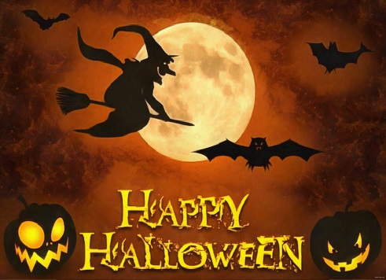 2

What has a lot of words but never speaks? This place is full of them. There you can find your next clue.

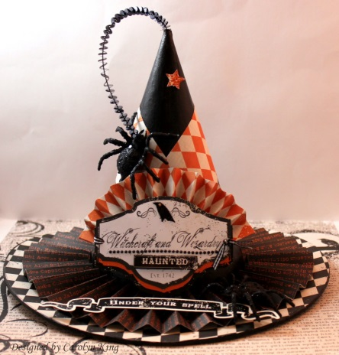 4

I am a large musical instrument with a row of black and white keys that are pressed to play notes. I have a clue. Come and get it. I’m waiting for you.

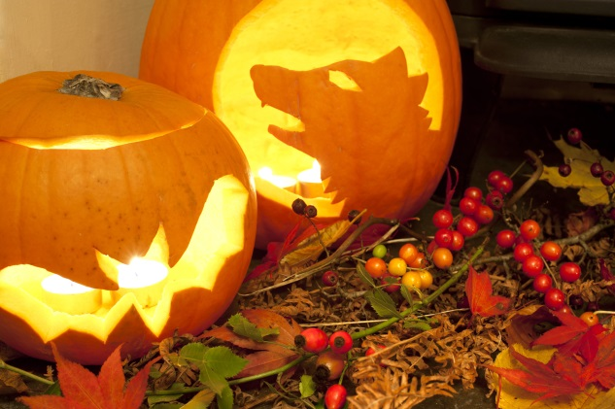 3

Abracadabra!!! are the magic words. She’s got a broom, wears black clothes and a black hat. She plays basketball. Ha….. Ha….. Ha……..Search around for your clue.

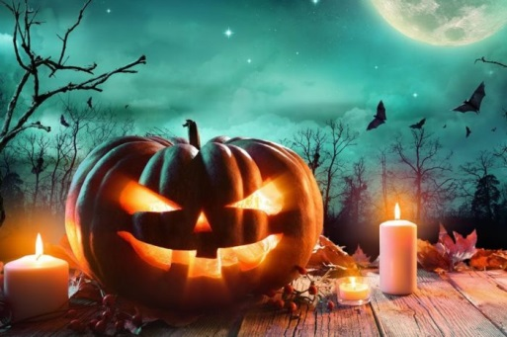 14

What has lakes with no water, mountains with no stones, and cities with no buildings? Your clue is there.

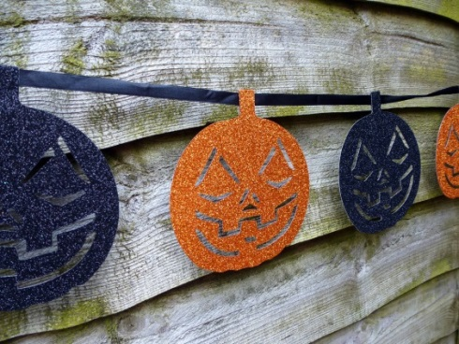 15

I’m found in the garden or the park, Sometimes even on the sidewalk. You can sit on me and eat your lunch, But don’t go to sleep – just a hunch!

ΛΥΣΕΙΣ
1. THE ALPHABET
2. LIBRARY
3. PLAYGROUND
4. THE PIANO
5. KINDERGARTEN
6. DRAWER
7. THE TEACHERS’ ROOM
8. PUMPKIN
9. WINDOW
10. COMPUTER
11. TREE
12. CHAIR
13. HEADMASTER’S OFFICE
14. MAP
15. BENCH
16. BLACKBOARD
17. TRICK OR TREAT

