Xanthi  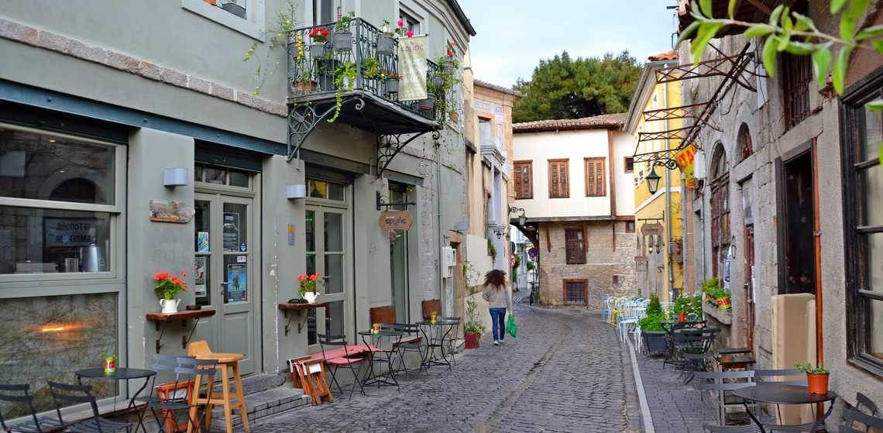  Information  Location: Thrace, northeastern Greece.  Population: about 112,000 people.  Landforms: Kosynhtos river runs through the city, near lake Vistonida, Livaditis river, the Nestos delta and gorge, the Thracian Sea.  Weather: cold winters, mild summers, mostly dry, windy and snowy. In winter, temperature drops to -10°C.  History and sights: about 6ooo years old (since the Neolithic era), the old town with traditional houses, old tobacco depots, the town clock, the open market, museums, Democritus University of Thrace, Police School for constables.  Traditions: the ‘Old Town’ festival, the carnival celebration and parade, youth festival, ‘Odos Oneiron’ festival dedicated to Manos Chatzidakis.  Food: kebab, traditional pasta, pickles, pies, cariocas, sweet pastries (baklava, kantaifi, saragli), lukum, kazan dipi, wine, tsipouro. | larissa  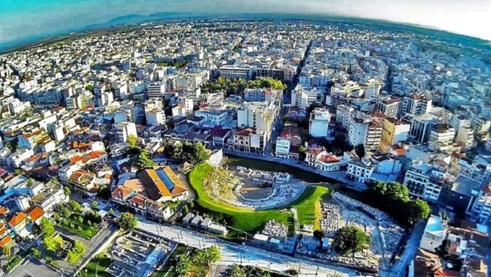  Information  Location: Thessaly, central Greece.  Population: about 280,000 people, 3rd largest city in Greece.  Landforms: Larissa valley, near Mt Ossa and Olympus, near the Tembi valley, to the river Pineios and the Aegean Sea.  Weather: hot and dry in summer, wet in winter. In summer, the temperature is known to climb to 43°C!  History and sights: over 4000 years old (since the Paleolithic era), the acropolis on Agios Achilios, two ancient theatres, the monument of Poseidon, Byzantine and Ottoman temples, baths, walls and an aqueduct, museums, historical buildings, parks and shopping centers.  Traditions: Artfools International Film Festival, Book Fair, the ‘Park of Wishes’ Christmas theme park.  Food: many types of cheese, pies, wine, tsipouro, meat dishes.  Notes | florina  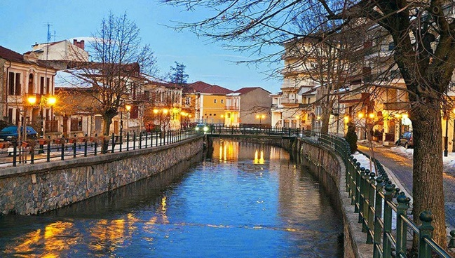  Information  Location: Macedonia, northwestern Greece.  Population: about 50,000 people.  Landforms: mountainous region, near Prespes lakes and lake Vegoritida, near Nymfaio village on Mt Verno where you can find the ‘Arcturos’ environmental centre, which is dedicated to protecting brown bears and wolves.  Weather: the coldest city in Greece (average temperature 12°C, mild summers, relatively dry, freezing cold winter (temperature has been known to drop to -25°C!)  History and sights: over 5000 years old (since the Age of Copper), historical buildings, museums, the University of Western Macedonia.  Traditions: Christmas bonfires, carnival celebrations.  Food: giant beans from Prespes Lakes, red florina peppers, mushrooms, chesnuts, apples, leeks, quinces.

