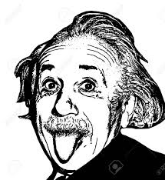
Name:_______________________________Class:_______Date:______
Albert Einstein-biography
Write the biography of Albert Einstein using the following information:
1879-(be) born in German.(be) a genius.(discover) the theory of relativity and the equation E=mc2.
1999-Time magazine (name) him as the person of the century.(be) really interested in science but (hate) learning by heart.(fail) his exams to a technical college.
At the age of 16 (perform) his famous experiment of imaging travelling alongside a beam of light.
1900-(graduate) from University,with a degree in Physics.
1912-(become) a university professor
1921-(win) a Nobel prize for physics-(publish) over 300 scientific papers
1955-(die) at the age of 76.
He changed the world with his theories and discoveries.
Some vocabulary to help you: genius=διάνοια//theory of relativity=η Θεωρία της Σχετικότητας //learn by heart=αποστηθίζω//experiment=πείραμα// university=πανεπιστήμιο//degree=πτυχίο//graduate=αποφοιτώ-τελειώνω το πανεπιστήμιο//publish=εκδίδω

_______________________________________________________________________________________________________________________________________________________________________________________________________________________________________________________________________________________________________________________________________________________________________________________________________________________________________________________________________________________________________________________________________________________________________________________________________________________________________________________________________________________________________________________________________________________________________________________

